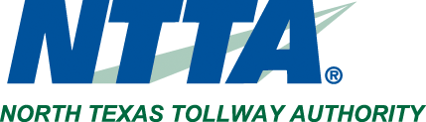  5900 W. Plano Parkway, Plano, Texas 75093 |  | Media Contact:  Michael Rey  214-224-2237  mrey@ntta.org

Media Notice

The North Texas Tollway Authority (NTTA) Board of Directors will conduct committee meetings Thursday, May 4, in the boardroom of the NTTA Administrative Offices located at 5900 W. Plano Parkway in Plano. The agendas are below.

Customer Service, Projects, and Operations Committee Meeting
Thurs., May 4
10:00 a.m.
Agenda

Finance, Audit, and Administration Committee Meeting
Thurs., May 4
10:15 a.m.
Agenda

About NTTA
The North Texas Tollway Authority, a political subdivision of the state of Texas, is authorized to acquire, construct, maintain, repair and operate turnpike projects across the North Texas region. The board of directors is comprised of Chairman Marcus Knight; Vice Chairman Mojy Haddad; and Directors Lynn Gravley, Pete Kamp, Scott Levine, John Mahalik, George “Tex” Quesada, Glen Whitley and Jane Willard.

NTTA is composed of member counties Dallas, Denton, Collin and Tarrant. It also serves Ellis and Johnson counties. NTTA owns and operates the Dallas North Tollway, President George Bush Turnpike, Sam Rayburn Tollway, Addison Airport Toll Tunnel, Lewisville Lake Toll Bridge, Mountain Creek Lake Bridge, Chisholm Trail Parkway, and 360 Tollway. It raises capital for construction projects through the issuance of turnpike revenue bonds. NTTA toll projects are not a part of the state highway system and receive no direct tax funding. Tolls are collected to repay debt and to operate and maintain the roadways.

###

