 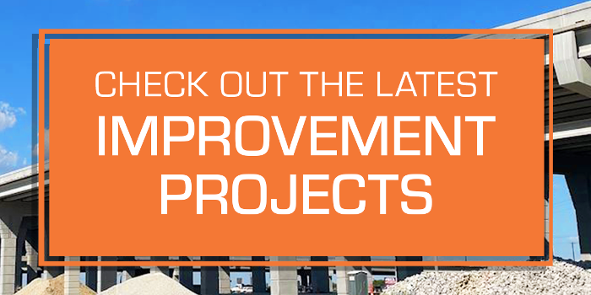

[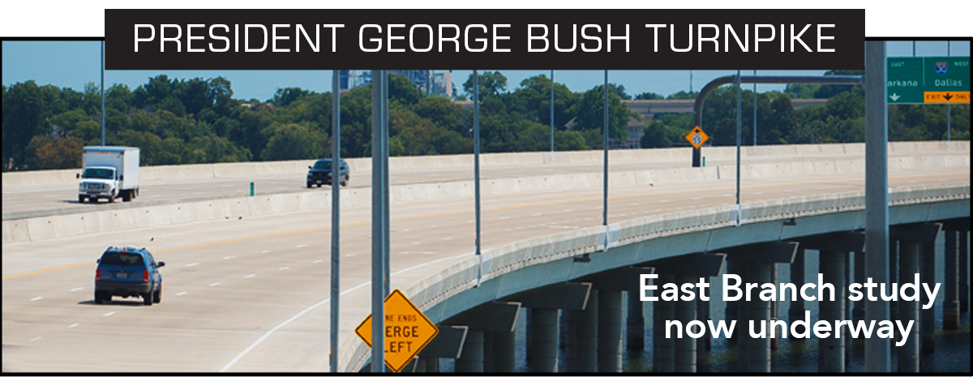](https://stage.ntta.org/president-george-bush-turnpike-pgbt#w-tabs-0-data-w-pane-0)

[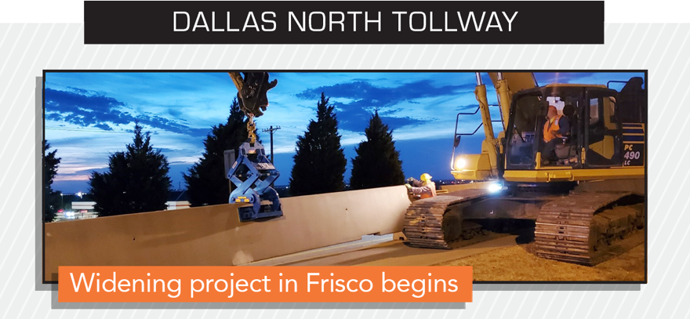](https://stage.ntta.org/dallas-north-tollway-dnt#w-tabs-0-data-w-pane-0)

](https://stage.ntta.org/dallas-north-tollway-dnt#projectstabphase4)